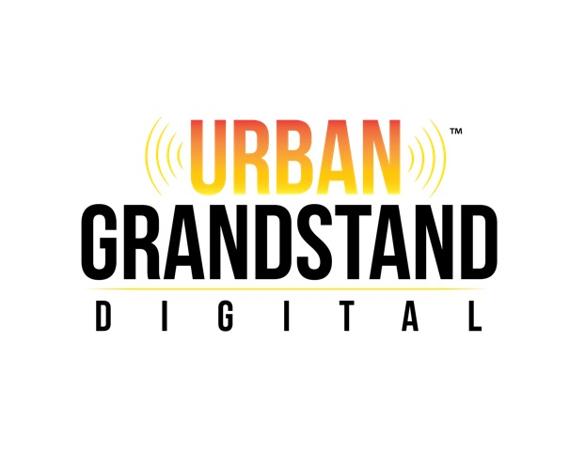

MEDIA KIT
WWW.UGDIGITAL.COM
(216) 673-8609

URBAN GRANDSTAND DIGITAL

Urban Grandstand Digital re-launched November 2013 as an online blog. The vision of Urban Grandstand Digital was to publish not only a blog, but also a highly detailed digital magazine, focusing on urban culture and entertainment. Based in Cleveland, Ohio, we would lead the industry as the first of our kind within Northeast Ohio. While covering national acts, stories, and more, we would also be deeply seated within our own community, offering support for that which was relevant here in the city.

The premiere issue of Urban Grandstand Digital released in May 2014. We initially released quarterly. Fully digital, we immediately offered subscriptions and single-issue digital downloads.

In June 2014, we were granted full access to cover the 2014 BET Live Experience & BET Awards, in Los Angeles, California.

In October 2014, we launched Urban Grandstand Live, and internet-run radio show that offers entertainment reporting and live interviews. Broadcasting once each week, the show immediately grew in popularity. Currently on a brief hiatus, Urban Grandstand Live is scheduled to return in May 2015, with full streaming to be available via UGDigital.com.

Since debuting, Urban Grandstand Digital has grown in popularity and now published monthly, as of December 2014.

In February 2015, we launched our 1st Mobile App, which allows full servicing of Urban Grandstand Digital to Android and Apple cellular phones. UGDigital.com is also mobile friendly, allowing seamless viewing through cellular phone web browsers.

In March 2015, we provided a FULL STREAM of the 2015 Stellar Awards Pre-Show and Red Carpet Ceremonies via UGDigital.com

In April 2015, we provided full media coverage to the stage play, Strength of Love, taking place in Griffin, Georgia.

In April 2015, we provided full media coverage for the SHEEN Magazine “Legendary Weekend”, honoring publisher Kimberly M. Chapman, and featuring hosts Porsha Williams, Claudia Jordan, Andrea Kelly,

In May 2015, we provided FULL STREAMING of the 20-Year Anniversary Documentary of Adina Howard’s recording career. Titled AdinaHoward20, this special event was broadcast directly from UGDigital.com
In August 2015, in addition to that month’s issue with cover artist Ro Brooks, we also released a full issue devoted to Faith Evans and her 20th Anniversary in the music industry. Not only did this issue include exclusive interviews and comments from various producers and engineers involved in the recording process, Faith Evans also took part in the issue, granting a full exclusive interview to our staff.

In September 2015, we provided media coverage for both The Ohio Hip Hop Awards, and The Greater Cleveland Urban Film Festival.

Cover artists have included:

2014: Jerrell Hodge (Professional MMA Boxer), Darnell Pettis (Professional MMA Boxer), Angela Robinson (Tyler Perry’s The Haves & The Have Nots)

2015: Brad James (Tyler Perry’s For Better or Worse, Sons 2 The Grave), Messiah Harris (T.I. & Tiny’s Family Hustle, Sons 2 The Grave), Trevor Jackson (Sons 2 The Grave, Atlantic Recording Artist), Justin Martin (Sons 2 The Grave), Judi C Hill (NAACP), Joy Villa, Nafeesa Monroe, Jerome “Ro” Brooks, Faith Evans

Other features include: Mykelti Williamson, Producer Lynne Stoltz, Meelah Williams, Mariah Howell, Darrin Dewitt Henson, Milyn Jensen, Roy Wood Jr., Chanté Moore, Chandra Currelley, Fefe Dobson, Francesco, Cormega, Traci S. Campbell, Tracey Lee, Maria Bazile, Dwayne Cottle, Paula Campbell, Gary Owen, Jay Ellis, Michael Colyar, Luenell, Tonya Cannon-Boyd (NBC’s The Voice), Kristinia DeBarge, Tamina Pollack-Paris, Calvin Richardson, Traci Braxton, Tahj Mowry, R.L. (formerly of N.E.X.T.), IAm PR Agency, Marsha S. Blake (Orange is the New Black), Teedra Moses, Teenear, Toi Troutman-Walker, Brave Williams, Nefee & Soullow, Noel Gourdin, & more.

Prior to 2013

Prior to 2013, we were known as Urban Connectionz Online. Between it’s launch in 2002 and it’s closure in 2010, Urban Connectionz Online operated solely as a blog, still representing urban culture and entertainment. During this time, we promoted an infinite list of artists through review, interview, and special features.

URBAN GRANDSTAND DIGITAL AVAILABILITY

Currently, we are working to place a select amount of print copies within various local establishments in an effort to increase awareness beyond our primary digital format. We are available through multiple digital publishers, including

- Joomag
- Issuu
- Magzter
- MagCloud
- Yumpu

Each of the aforementioned digital publishers offer mobile apps for Android and Apple devices.

We also have our own mobile app, which can be downloaded on both the Android and Apple platform for FREE.

Each issue is available by connecting to www.ugdigital.com and clicking the link for The Magazine.

Both single issues, and subscriptions can be ordered.

Print copies can be ordered, and we also allow printing directly to your home/office printers through particular apps.

SOCIAL MEDIA

Facebook: http://www.facebook.com/urbangrandstanddigitalmag
Launched: May 2014
Followers: 470

Instagram: @urbangrandstanddigital
Launched: December 2014
Followers: 1330

Twitter: @grandstandurban
Launched May 2014
Followers: 2187

Newly Created Social Media Presence as of April 2015

- SnapChat
- Flickr
- Periscope
- Kik
- Pinterest
- Foursquare
- Soundcloud
- Mixcloud
- Tumblr

PRESS RELEASE

Urban Grandstand Relaunches

Cleveland-based Online Magazine relaunches after a near two year hiatus.

Cleveland, OH, October 09, 2013 --(PR.com)-- Following a near two year hiatus, Cleveland-based online magazine Urban Grandstand has re-launched.

Operated most times throughout the past decade as a one-man show, the site shut down indefinitely in 2010 for various reasons. The company’s publisher, James Johnson, speaks candidly about the short hiatus....

"Urban Grandstand has been my baby; so to speak, for more than a decade. It actually began as Urban Connectionz in 2002, and there have been so many successful moments throughout that time. First and foremost, as someone with no Journalism experience in the beginning; yet having a strong desire to gain that experience, it was a way for me to have my own vehicle, and get to that next level. When people were constantly telling me no, it was a way for me to bypass those people and get what I wanted. I've had the tremendous blessing of interviewing hundreds of artists, musicians, television, and film stars over the years. During those years, I took things a step further by pursuing my education. In retrospect, shutting down for a short period was the best thing I could have done, because it allowed me to focus on my educational goals, and I've been able to earn multiple degrees in Journalism. I can now use this vehicle to truly take the Journalism world by storm, and show another side than what people have been used to seeing out there."

While the online home has been set up and is fully accessible, the official re-launch will not be for a few more weeks. "I purposely opened the domain to be fully accessible, because I want people to be able to see the building stages as we come along over the next few weeks. We will be uploading a great deal of past material, interviews, and so forth into the site, as I know many will want to be able to view these things and see our progress. The blessing is that we'll now have a strong team of writers who will be contributing to the magazine, unlike before when it was primarily myself."

In terms of the team that's been put in place, Urban Grandstand Digital continues to add to the stable of strong journalists and writers. For more information on Urban Grandstand, or to inquire about contributing, visit www.ugdigital.com, or contact info@urbangrandstand.com.

CONTACT DETAILS

Name: James Johnson
Title: Publisher
Telephone: 216-457-3007
Cell: 216-816-6506
Email: james.johnson@urbangrandstand.com
Website: www.ugdigital.com

Feature & Press Inquires: urbangrandstandinfo@urbangrandstand.com

Postal:

Urban Grandstand Digital
5988 Bear Creek Drive, Ste. 310
Bedford Heights, OH 44146

