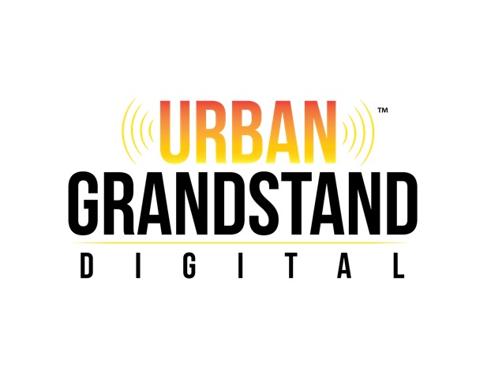

2015
Advertising
Rate Card

Advertisement Specs (Magazine) | 1 issue | 3 issue | 6 issue
Full Page | $125 | $115/mo. | $105/mo.
¾ Page | $100 | $95/mo. | $90/mo.
½ Page Island | $75 | $70/mo. | $65/mo.
½ Page Horizontal | $75 | $70/mo. | $65/mo.
1/3 Page Vertical  1/3 Page | $65 | $60/mo. | $55/mo.
¼ Page  ¼ Page Vertical  ¼ Page Horizontal | $50 | $45/mo. | $40/mo.
1/6 Page Vertical  1/6 Page Horizontal | $45 | $40/mo. | $35/mo.
1/8 Page | $40 | $35/mo. | $30/mo.
Business Card Size | $25 | $20/mo. | $15/mo.
Premium Advertisement Specs | 1 issue | 3 issues | 6 issues
Inside Front Cover | $250 | $225/mo. | $200/mo.
Inside Back Cover | $200 | $175/mo. | $150/mo.
Back Cover | $250 | $225/mo. | $200/mo.

Urban Grandstand Digital was re-launched, first as an online blog in November 2013, progressing to a full magazine in May 2014. In June 2014, Urban Grandstand Digital provided media coverage for the 2014 BET Experience & Awards.

Features since re-branding have included Comedians Gary Owen & Roy Woods Jr, as well as Tracey Lee, Andre Pitré, Ed Reinbergs, JD Era, Milyn Jensen, Meelah, K-Slick, Darrin Dewitt Henson, Angela Robinson, Mykelti Williams, Brad James, Messiah Harris, Trevor Jackson, Justin Martin, Maria Howell, A5kem, Lynne Stoltz, Traci S. Campbell, NAACP President Judi C. Hill, Priyanka Banks (VH1’s Sorority Sisters), Paula Campbell, Chandra Currelley, Chanté Moore, Ro Akin, Steven Russell (Troop), Jin, Francesco, Cormega, Fefe Dobson, Roy Wood Jr, & more.

Prior to May 2014, we were known/d.b.a. Urban Connectionz Online. Urban Connectionz Online was launched March 2002. As Urban Connectionz Online, features included Kelly Price, Juvenile, Big Boi (of Outkast), Kem, Lil’ Wayne, Murphy Lee, Sheek Louch, Krayzie Bone, Bizzy Bone, Flesh-n-Bone, Layzie Bone, Chrisette Michele, Lil’ Mo, Larvis, Mr. Cheeks, O’Ryan, Daz, Charlie Wilson, Young City, J. Anthony Brown, Remy Ma, Truth Hurts, Raphael Saadiq, Kool & The Gang, Mannie Fresh, SWV, Keyshia Cole, Jazze Pha, Ceelo, Jaheim, Hell Rell, Nicole Wray, Joe Budden, Wyclef Jean, Jha Jha, Paul Wall, Outlawz, Sean price, Pretty Ricky, Gerald Levert, Tweet, Jon B, Yolanda Adams, Youngbloodz, T-Pain, Mack 10, Lina, Jin, Killer Mike, Trey Songz, Webbie, Akon, Lil’ Scrappy, D4L, Sunshine Anderson, Yung Wun, Young Jeezy, Boyz N Da Hood, Angie Stone, Anthony Hamilton, Avant, B.G., Backbone, Janelle Monae, Bubba Sparxxx, Chingy, The Diplomats, Field Mob, Donell Jones, Bun B, Flo Rida, & more.

Urban Grandstand Live is a weekly radio broadcast centering around urban culture & entertainment. Urban Grandstand Live was launched November 2014. In addition to playing/promoting today’s relevant music, we feature a variety of guests centering around entertainment & urban culture, as well as other areas including sports, fashion, community and more. We broadcast each Thursday from 5pm-6pm EST. We will launch a weekly podcast beginning December 2015!

All premium positions are on a first-come, first-served basis. Specific page placement within the magazine is also available at a premium. Contact Urban Grandstand Digital’s advertising sales team for details.

Discounts and Payments

Discounting is based upon length of advertising campaign.
- Ad creation services are available for an additional service fee.

Frequency discounts are available and are based on the number of insertions run within a 12-month period from the date of first insertion. Any advertiser who does not fulfill a contract will be subject to short rates. Ad contracts may be cancelled provided notice is given before the closing date. Credits and rebates are earned by increasing frequency during a contract. Orders subject to rate change upon 90 days notice from publisher.
• Publisher reserves the right to hold the advertising agency and the advertiser jointly and severally liable for payments due the publisher. In the event that an advertiser has paid the agency, the advertiser is fully responsible for paying all invoices due the publisher.
• Advertising rates, terms and conditions set forth in this rate card shall govern all transactions and supersede any other information published in previous rate cards, directories, media guides or rate and data services. Uniform rates apply to all advertisers at all times.
• Neither the advertiser nor its agency may cancel advertising after the issue closing date. When change of copy is not received by closing date, copy furnished or run in previous issue will be printed.
• The publisher shall not be subject to any liability whatsoever for any failure to publish or circulate all or any part of any issue due to strikes, work stoppages, accidents, fires, acts of God, or any circumstance not within the control of the publisher.
• In the event of an error in the printing of a display advertisement, the publisher will re-run the correct version of the same ad material in the next available issue published.
• Publisher’s liability for any error will not exceed the cost of the advertisement’s space.
• Publisher reserves the right to add the word “Advertisement” to or reject advertising that simulates editorial.

2015 Release Calendar

Issue 3
Closing: 1/2/15
Release: 1/10/15

Issue 4
Closing: 2/6/15
Release: 2/12/15

Issue 5
Closing: 3/2/15
Release: 3/12/15

Issue 6
Closing: 3/19/15
Release: 4/9/15

Issue 7
Closing: 4/16/15
Release: 5/7/15

Issue 8
Closing: 7/16/15
Release: 8/13/15

Issue 9
Closing: 10/1/15
Release: 10/29/15

Issue 10
Closing: 12/1/15
Release: 12/29/15

